

# Report of Project Work For The Course HTML And CSS (CSE-326)

I Regds No:- 12217573 here by declare that the project work reported entitled “Travelling Website” in partial fulfilment of the requirement for the award of Degree for Bachelors of Technology in CSE at Lovely Professional University, Jalandhar, Punjab is an authentic work carried out under supervision of my supervisor Mr. Sushil Lekhi. The content of this project represents authentic and honest effort conducted, in its entirely by us. We are fully responsible for the contents of our project.

# NAME : Parth s Pandey REGISTRATION NUMBER: 12217573



**Report of Project Work For The Course HTML And CSS (CSE-326)**

# Group Members:-

**Name Registration Number Roll no.**

Parth Pandey 12217573 68

Ankit Kumar 12222386 52

Yash Pandey 12215960 70

**Submitted to-** **Mr. Sushil Lekhi**

**SCHOOL OF COMPUTER SCIENCE AND ENGNEERING LOVELY PROFESSIONAL UNIVERSITY, JALANDHAR, PUNJAB, INDIA**

# DECELERATION

We Regds No:- 12217573 , 12222386 , 12215960 here by declare that the project work reported entitled “Travelling Website” in partial fulfilment of the requirement for the award of Degree for Bachelors of Technology in CSE at Lovely Professional University, Jalandhar, Punjab is an authentic work carried out under supervision of my supervisor Mr. Sushil Lekhi. The content of this project represents authentic and honest effort conducted, in its entirely by us. We are fully responsible for the contents of our project.

Parth Pandey (Regs. No. 12217573)

Ankit Kumar(12222386)

Yash Pandey (12215960)

**INDEX**

|  |
| --- |
| **POINTERS TOPIC** |
| **1.1 INTRODUCTION** |
| **1.2 PROJECT** |
| **1.3 CODE** |
| **1.4 RESULT** |

**1.1 INTRODUCTION :-----------------------**

## HTML

HTML is an acronym which stands for Hyper Text Markup Language which is used for creating web pages and web applications. Let's see what is meant by Hypertext Markup Language, and Web page.

Hyper Text: Hyper Text simply means "Text within Text." A text has a link within it, is a hypertext. Whenever you click on a link which brings you to a new webpage, you have clicked on a hypertext. Hyper Text is a way to link two or more web pages (HTML documents) with each other.

Markup language: A markup language is a computer language that is used to apply layout and formatting conventions to a text document. Markup language makes text more interactive and dynamic. It can turn text into images, tables, links, etc.

## CSS

Cascading Style Sheets, fondly referred to as CSS, is a simply designed language intended to simplify the process of

making web pages presentable. CSS allows you to apply

styles to web pages. More importantly, CSS enables you to do this independent of the HTML that makes up each web page.

It describes how a webpage should look: it prescribes colors, fonts, spacing, and much more. In short, you can make your website look however you want. CSS lets developers and designers define how it behaves, including how elements are positioned in the browser.

While html uses tags, css uses rulesets. CSS is easy to learn and understand, but it provides powerful control over the presentation of an HTML document.

1.2 **PROJECT---------------------------**

**Hotel website**

**1.3 CODE---------------------**

**Home:-**

## HTML

|  |
| --- |
| <!DOCTYPE html>  <html>  <head>  <title>Travel Website</title>  <link rel="preconnect" href="https://fonts.gstatic.com">  <link href="https://fonts.googleapis.com/css2?family=Poppins:wght@300&display=swap" rel="stylesheet">  <link rel="stylesheet" type="text/css" href="travel_website.css">  </head>  <body> <style> body{  background-image: url(03.jpg);  }  </style>  <div class="navbar">  <div class="logo">  <h1>Explore The World</h1>  </div>  <div class="menu">  <ul type="none">  <li><a href="./travel_website.html">Home</a></li>  <li><a href="./services.html">Services</a></li>  <li><a href="./gallery.html">Gallery</a></li>  <li><a href="#">Booking</a></li>  <li><a href="contact_us.html">Contact Us</a></li>    </ul>  </div>  <div class="signup"> |

|  |
| --- |
| <a href="./sign.html">Sign Up</a>  </div>  </div>  <div class="body">  <div class="heading">  <h1>Travel With Us</h1>  <br>  <p>Travelling is one of the best hobbies, that one can have. It offers an opportunity for adventure.  So, let's begin the Journey full of adventures. </p>  <br>  <br>  <a href="#">Learn More</a>  </div>  <div class="tours">  <div class="places">  <h2>Australia</h2>    <br><img src="Austraila tourist place.jpg" style="width:  300px; height: 250px; border-radius: 12px;">  <br>  <a href="#">Book Now 15% OFF</a>  </div>  <div class="places">  <h2>Bangkok</h2>  <img src="tourist place in bangkok.webp" style="width: 300px; height: 250px; border-radius: 12px;">  <br>  <br>  <a href="#">Book Now 20% OFF</a>  </div>  <div class="places">  <h2>India</h2>  <img src="India.2.jpg" style="width: 300px; height: 250px; border-radius: 12px;"> <br>  <br>  <a href="#">Book Now 25% OFF</a>  </div>  </div>  </div>  <div class="footer">  <a href="#">Copyright</a>  <a href="#">Terms and Conditions</a>  <a href="#">Privacy Policy</a>    <a href="#">Complaints</a>  </div> |

</body>

</html>

## CSS

|  |
| --- |
| { padding: 0px; margin: 0px; box-sizing: border-box; list-style: none; font-family: 'Poppins', sans-serif;    } .navbar{ width: 100%; height: 80px; background-color: #fee; display: flex; justify-content: space-around; align-items: center; color: #000;  }  .menu ul{ display: flex; align-items: center;  }  .menu ul li a{ text-decoration: none; color: #000; padding: 5px 12px; letter-spacing: 2px; font-size: 18px;  }  .menu ul li a:hover{ border-bottom: 4px solid #000; transition: 0.4s;  }  .signup a{ text-decoration: none; color: #000; |

|  |
| --- |
| font-size: 18px; font-weight: bold; border-radius: 12px; padding: 12px 30px; border: 2px solid #ff0000;  }    .signup a:hover{ background-color: red; transition: 0.6s;  } .body{ width: 100%; height: 90vh; display: flex; justify-content: space-around; align-items: center; background-image: lineargradient(rgba(0,0,0,0.50),rgba(0,0,0,0.50)),url(img1.jpg); background-position: center; background-size: cover;  }  .heading{ width: 30%; text-align: center; color: #fff;  }  .heading h1{  font-size: 40px;  }  .heading a{  text-decoration: none; color: #000; font-size: 25px; font-weight: bold; border-radius: 45px; padding: 14px 50px; background-color: #fff;  }  .heading a:hover{ letter-spacing: 3px; transition: 0.6s;  } .tours{ width: 70%; display: flex; justify-content: space-around;  } |
| .places{ display: inline; text-align: center; border-radius: 12px;  }  .places h2{ color: red; font-size: 35px; letter-spacing: 3px; border-radius: 1px; padding: 30px 30px; background-color: #000;  }  .places a{ text-decoration: none; color: red; font-weight: bold; font-size: 18px; border-radius: 12px; padding: 12px 30px; background-color: #fff;  }  .places a:hover{ background-color: #000; letter-spacing: 3px; transition: 0.6s;  } .footer{ width: 100%; height: 50px; display: flex;  justify-content: space-around; align-items: center;  }  .footer a{ text-decoration: none; color: green; font-size: 18px; font-weight: bold;  }  .footer a:hover{ text-decoration: underline; transition: 0.4s;  } |

## SERVICES:-

HTML

|  |
| --- |
| <!DOCTYPE html>  <html lang="en">  <head>  <meta charset="UTF-8">  <meta http-equiv="X-UA-Compatible" content="IE=edge">  <meta name="viewport" content="width=device-width, initial-scale=1.0">  <title>Document</title>  </head>  <body> <style> body{ background-image: url(GOA_01.jpg); }  </style>  <h1><center>OUR SERVICES</center></h1>  <p> 1. We will take you to different places in the World at the very affordable price. <br>   1. Tourist guide book will be provided to you and you have to follow the instructions mention there.<br> 2. We provide free food and accomodations to the costumers. <br> 4. Maintainance of hygenic environment throughout the journey is our first priority. <br> 3. To avoid any inconvenient cause we provide two guards for every trip. <br> 4. Your's safety is our's safety.</p>   </body>  </html> |

## GALLERY:-

HTML

|  |
| --- |
| <!DOCTYPE html>  <html lang="en">  <head>  <meta charset="UTF-8">  <meta http-equiv="X-UA-Compatible" content="IE=edge">  <meta name="viewport" content="width=device-width, initial-scale=1.0">  <title>Document</title>  <style> #color{ background-color:chartreuse;  } .flex{ display: flex;  }  </style>  </head>  <body><div id="color">  <h2><center>India</center></h2></div>  <div class="flex">  <div> <img src="/vanaras_01.jpg" width="350px"></div>  <div> <img src="/vanaras_03.jpg" width="350px"></div>  <div> <img src="/India.1.jpg" width="350px"></div> <div> <img src="/India.2.jpg" width="350px"></div>  </div>  <br>  <br>  <div><h2 style="background-color:  chartreuse;"><center>Australia</center></h2></div>  <div class="flex">  <div> <img src="/Austraila tourist place.jpg" width="350px"></div>  <div> <img src="/Aus.2.jpg" width="350px"></div>  <div> <img src="/Aus.3.jpg" width="350px"></div>  <div> <img src="/Aus.4.jpg" width="350px"></div>  </div>  <br> |

<br>

<div><h2 style="background-color:

chartreuse;"><center>Bangkok</center></h2></div>

<div class="flex">

<div> <img src="/Bangkok.1.jpg" width="350px"></div>

<div> <img src="/Bangkok.2.webp" width="350px"></div>

<div> <img src="/Bangkok.3.jpg" width="350px"></div>

<div> <img src="/Bangkok.4.jpg" width="350px"></div>

</div>

</body>

</html>

CONTACT US:-

HTML

|  |
| --- |
| <!DOCTYPE html>  <html lang="en">  <head>  <meta charset="UTF-8">  <meta http-equiv="X-UA-Compatible" content="IE=edge">  <meta name="viewport" content="width=device-width, initial-scale=1.0">  <title>Document</title>  </head>  <body style="background-color: rgb(128, 128, 128);">  <body> <style> body{ background-image: url(background.04.jpg);  }  </style>  </body>      <h1><center>Contact Us</center></h1>  <p><center>This website is created by our team for helping people to change their hobbies of travelling into reality and exploring World.</p><br> For any business related issues you can contact our company Director and mail him and your mail will be reverted within 48 working hours, so feel free to contact us.</center>    <h2><center>Ravi Singh(Programmer)</center></h2>  <h4><center>email: singhravi80096@gmail.com</center></h4>  <h4><center>Mob. no: 8009622446</center></h4> |
| <h4><center>Twitter:<a href="https://twitter.com/Ravi_officials_?t=_FjZaEKwNk4nKr4_2RRfpw&s=08">twitt er.com</a></center></h4>    <h2><center>Shivanshu Singh(Designer)</center></h2>  <h4><center>email: shivanshu22@gmail.com</center></h4>  <h4><center>Mob. no: 8953139661</center></h4>  <h4><center>Twitter: @shivanshu22_officials_</center></h4>  <h2><center>Divyanshi Singh(Content creator)</center></h2>  <h4><center>email: divyanshisingh@gmail.com</center></h4>  <h4><center>Mob. no: 7394868388</center></h4>  <h4><center>Twitter: @divyanshi.singh_officials_</center></h4>          </body>  </html> |

## SIGN UP:-

HTML AND CSS

|  |
| --- |
| <!DOCTYPE html>  <html lang="en">  <head>  <meta charset="UTF-8">  <meta http-equiv="X-UA-Compatible" content="IE=edge">  <meta name="viewport" content="width=device-width, initial-scale=1.0"> <title>registration form</title>  <link rel="stylesheet" a href="/aking/signup.css">  <style> *{ margin:0; padding: 0;  } body{ background-color: rgb(180, 157, 140); |

|  |
| --- |
| background-image:url(/aking/images.jpeg); background-repeat: no-repeat; width:100%; position: absolute; background-size:100%;  /* background-position: -400px 0px; */  } div.main{ width: 400px; margin:100px auto 0px auto;  } h2{ text-align: center; padding:20px; font-family: sans-serif;  } div.register{ background-color:rgba(0,0,0,0.5); width:100%; font-size: 18px; border-radius: 18px; box-shadow:2px 2px 15px rgba(0,0,0,0.3); color:darkorange  }  form #register{ margin:40px;  } label{ font-family:sans-serif; font-size:15px; font-style:initial;  } input#name{ width:300px; border:1px solid red; border-radius:3px; outline:0; …  </style>  </head>  <body>  <div class="main">  <div class="register">  <h2>Register Here</h2>  <form id="register" method="post">  <label>First Name: </label>  <br> |
| <input type="text" id="name"placeholder="Enter your first name">  <br><br>  <label>Last name: </label>  <br>  <input type="text" id="name"placeholder="Enter your last name">  <br><br> <label> Age:  </label>  <br>  <input type="number" id="age"placeholder="Enter your age">  <br><br>  <label>Email id:</label>  <br>  <input type="email" id="email"placeholder="Enter your email">  <br><br>  <label>Gender : </label>  <br>  &nbsp;&nbsp;&nbsp;  <input type="radio" name="gender" id="male">    <span id="male">Male</span>  &nbsp;&nbsp;&nbsp;  <input type="radio" name="gender" id="female">  &nbsp;&nbsp;&nbsp;  <span id="female">Female</span>  &nbsp;&nbsp;&nbsp;  <input type="radio" name="gender" id="other">  <span>Other</span>  <br><br>      <input align="center" type="submit" value="Submit" name="submit" id="submit">  </form>  </div>  </div>  </body>  </html> |

### 1.4 RESULT---------------------

Home page view:-

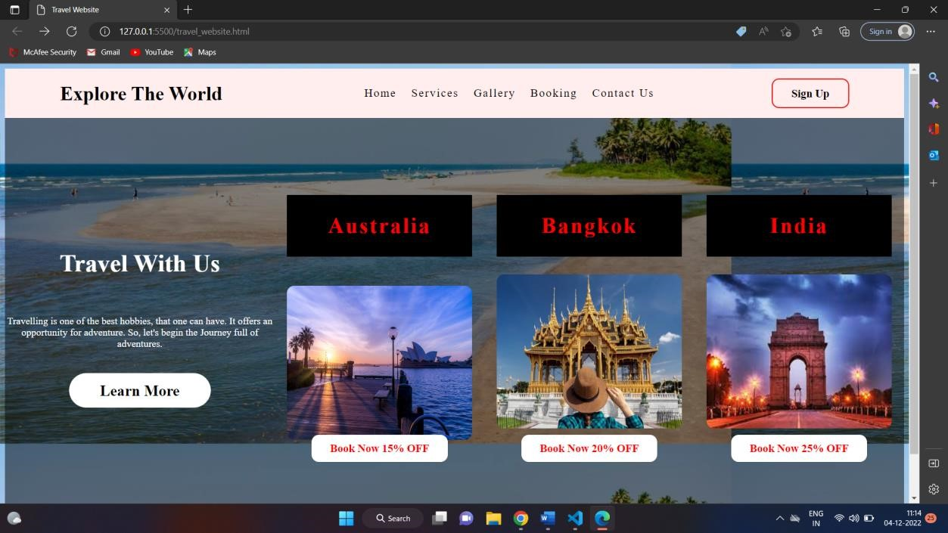

Services page view:-

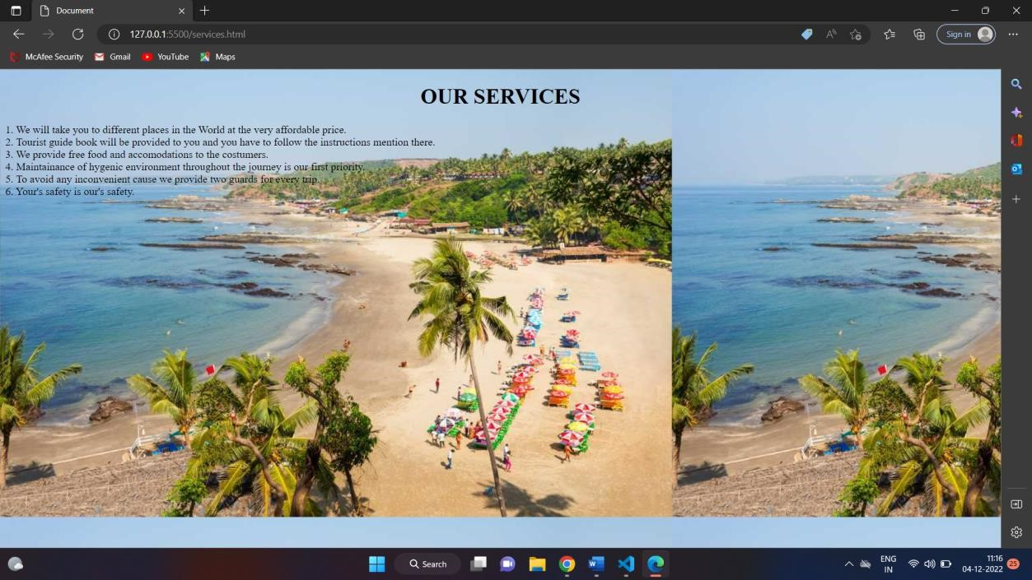

Gallery page view:-

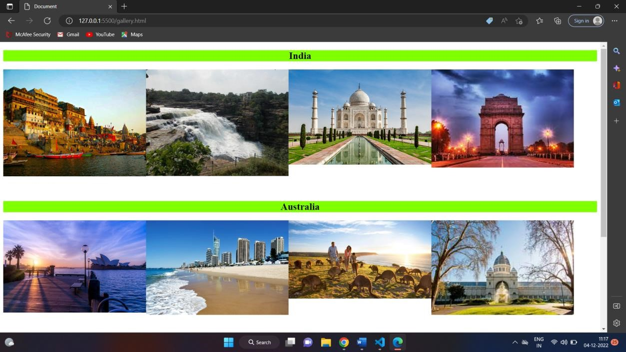

Contact us page view:-

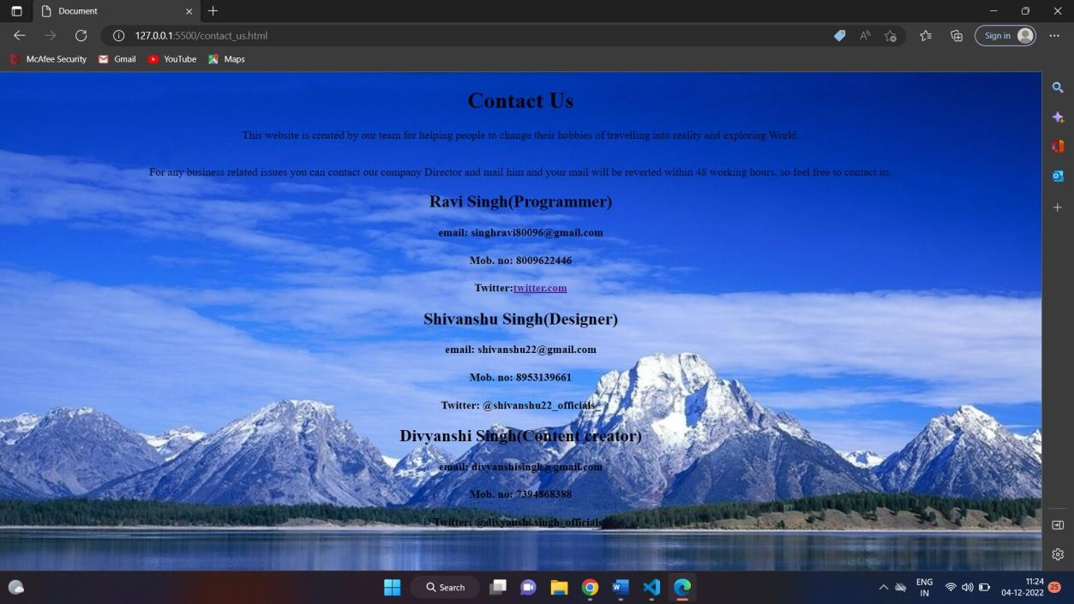

Sign up page view:-

